John Bernard Christian – January 2, 1927- September 26, 2018
Distinguished Scientist, Inventor, Entrepreneur, Veteran, Husband and Father
The story of John B. Christian, is one of our nation’s most hidden treasures. Like so many distinguished and innovative African American’s, his story and accomplishments are unknown to the public at large, but without his intellect, perseverance and innovation, many of our nation’s greatest accomplishments such as space travel, putting a man on the moon, defense of our country and protecting the lives of so many military personnel in the Vietnam War would never have been achieved. This is the story of John Christian – notable African American Scientist, Inventor, Entrepreneur, World War II Veteran of the United States Navy and Korean War Veteran of the United States Army, Husband and Father.
Family History
John was Born in Marietta Georgia – Jan 2, 1927 to Susie Mae Martin Christian (1910 – 2002) and Oscar Christian (1907 – 1975). Within the first year of his life, John’s parents separated and he was raised by his mother and grandmother Jimmie Lou Brooks Martin (1892 - ?) on a farm, 3 miles from Marietta, GA. To support her son, John’s mother, Susie Mae (Sue), would leave John with his grandmother and her sisters, Jack and Pearl Ann Elizabeth to secure one of the only forms of employment available to a Negro woman at the time – tending household chores and cooking for a white family. Sue had to move to Louisville, KY and would send money home to her mother Jimmie Lou to take care of her son, John. Life with his grandmother was meager at best, but John was well cared for. His grandmother, known for her great cooking, raised chickens and hogs, and prepared delicious meals including “ice box” cakes that John enjoyed on special occasions – mostly holidays or when the local preacher came to call for Sunday dinner.
Jimmie Lou raised her children alone as her husband, Charles James Martin, Sr. died in his 40’s from a stray bullet fired by military personnel practicing maneuvers in a field nearby their home. Jimmie Lou and Charlie Martin had 6 other children – daughters Carrie Su Martin, Charley Lou Martin, Willie Lee Martin and Ruby Martin Hill. They also had two sons – Charles James Martin, Jr. and Ruben Martin. Jimmie Lou had an interesting heritage. Her mother Sylvia was the daughter of Native Americans – her mother of Black Foot and Cherokee decent and her father was Negro.
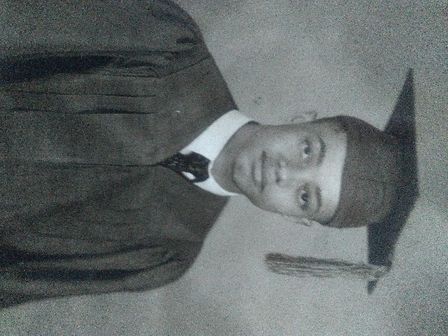
John lived with his grandmother until she passed away when he was 7 years old. He then moved to Harlan, Kentucky to live with his mother’s sister Pearl and her husband Horace Dutton until he was about 10 years old. Pearl and Horace couldn’t have children of their own and loved John as their own. Horace always referred to John as “my boy.” At about 10 years old, John went to live with his mother Sue in Louisville, KY. Pearl and Horace also moved to Louisville and asked Sue to let John live with them again. They enrolled John into the Catholic School, St. Augustine Elementary, in Louisville, KY given the public school wouldn’t allow John to enroll because he moved in the middle of the school year. John attended St. Augustine and liked it so well that he asked to remain, rather than attend public school when he was eligible. John was encouraged and greatly supported by the nuns who saw the talent and intelligence in this young student, even though his grades from his previous public school didn’t reflect his true potential. John flourished in his new environment, always the top student in his class. Upon graduation from St. Augustine elementary school, he attended St. Augustine High School and graduated with honors in June 1945.
John never saw his father growing up. Oscar Christian was one of 17 known brothers and sisters and 6 half-sisters. In later years, John would forge a close relationship with his uncle Henry T. Christian (aka Ted 1908- 1972) and his wife Pattie (1910 – 2007) and their children, his cousins, who lived in Dayton, Ohio. When John’s father Oscar was dying of cancer in 1975, John went to Marietta to support him. During one of his visits, John learned he had a brother, Ralph Christian, a fact that his father kept from him all his life. Although John and Ralph never knew each other growing up, they forged a strong brotherly bond until Ralph’s death in 2004. John supported Ralph and his family - wife Gloria, sons Ralph Jr. and Remely and daughter Mimi.
Military History and Continued Education
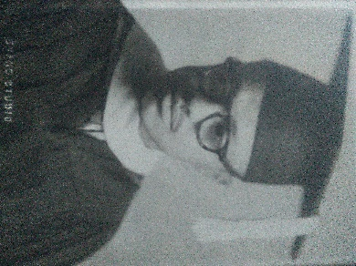
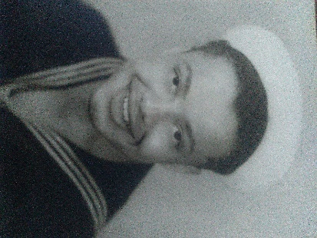
When John turned 18 in 1945, he was immediately drafted in the Navy as the United States was still engaged in World War II. At the close of the war, John was released from active duty with an honorable discharge in August 1946. Upon release, John attended the University of Louisville under the GI Bill and obtained a Bachelor of Science degree in Chemistry in 1950, graduating with honors. He was also awarded membership in the Beta Kappa Chi National Honorary Scientific Society in 1950. While at the University of Louisville, John became a member of the Alpha Phi Alpha fraternity and remained an active member throughout his entire life, attending local gatherings and meetings wherever he lived.
After graduation, John’s intent was to seek employment as a chemist; however, in 1950, the United States engaged in the Korean War, and John, at the age of 23 was drafted again, this time in the Army and sent to Korea. Because John was drafted in the Navy in World War II, he was only to serve 2 years in the Korean War. There was much debate about him being drafted for a second time because men were only supposed to be drafted once in a lifetime.
John quickly advanced from Private to Corporal, receiving the Purple Heart for injuries sustained in battle. As a distinguished soldier receiving battlefield commission and honors (2 Bronze Stars and the United States Service Medal), the Army “offered” John to remain in service with a promotion to Lieutenant. John was not interested in a military career though. John witnessed tremendous atrocities in the trenches. He described “waves of Chinese” attacking his platoon, describing massive killings on both sides of the line. The taking of human life and witness of the slaughter of comrades and enemy forces took its toll. John was honorably discharged in 1956 and he returned to Louisville, KY.

United States Government Career
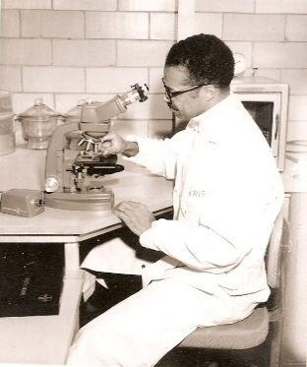
Upon return from duty, John found a job in Louisville, KY. In the early- 1950’s John moved to Indiana where he was offered a job at the Pillsbury company but they rescinded the offer because Whites did not want to work with a person of color and threatened to quit if John was hired. John was offered a job 3 days later by the DuPont company in Indiana where he worked for a couple of years, until a contract DuPont had with the military came to an end. John and many other employees were subsequently let go by DuPont but John was recognized for his work as a chemist and hired by the United States Navy in Washington, D.C. to continue the work he was doing previously at Dupont. John was first recruited to work on formulations for new explosives. Due to the highly classified nature of his work, it was unknown to anyone, except close family members (but not until he was in his 80’s) some of the projects he worked on. One such development was the creation of C-4 otherwise knowns as Composition C-4. C-4 is a plastic explosive that is probably one of the greatest advancements in explosive technology ever created. John developed C-4, in 1956 and to date, there is still no explosive that rivals its power and flexibility of use. The greatest advantage of C-4 is that it is very stable and less sensitive to physical shocks and heat making it relatively safe to handle. It can be easily molded into any desired shape, helping direct the explosion. Originally developed for demolition, C-4 was also used extensively in the military. When asked where the name came from, John explained, “The C stands for Christian and the 4 signified the 4th formulation created before success was achieved.”
Wright Patterson Airforce Base Career
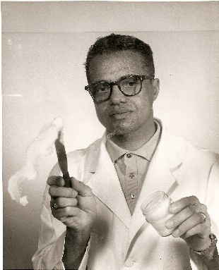
Recognized for his work, John was offered a transfer to the Materials Research Laboratory at Wright Patterson Airforce Base in Dayton, Ohio. John accepted the position and moved to Dayton around 1956 John had a distinguished career at Wright Patterson as a Materials Research Engineer, inventing and patenting new greases and lubricants in high flying aircraft and equipment for the military and NASA space craft. The applications were endless.
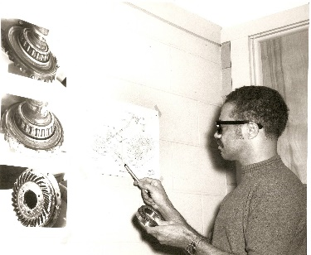
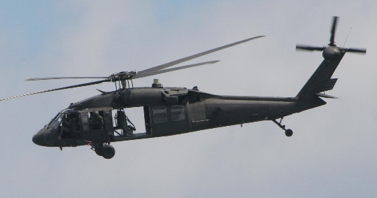
For example, some of John’s lubricants were used as a replacement to the more viscous oils used in helicopter fuel lines, saving countless US military lives in the Viet Nam War. The enemy often targeted the fuel lines with gunfire causing the fuel and oils to drain and the helicopters to crash, resulting in many casualties and failed missions. When a prominent General’s son was killed in one of these failed missions, John was commissioned to develop a solution. John developed a heavier grease based lubricant that replaced the oil based lubricants. Now, when the fuel lines were targeted, the heavier greases did not drain, allowing the helicopters to remain airborne, saving countless lives and the success of many missions. Igor Sikorsky, the founder of Sikorsky Aircraft was so impressed with John’s new development that he insisted on meeting the young man that “…dared to put grease in my helicopters.” John not only met Igor Sikorsky, but he also forged a long- lasting relationship with him and Sikorsky Aircraft over the years.
Vietnamese soldiers often targeted the fuel lines in the tail of US helicopters, taking them down.
Demonstrating how lubricants “float” in space
John Christian demonstrating how his lubricants would work with Sikorsky Black Hawk Helicopter Bearings and Gears
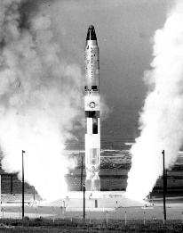
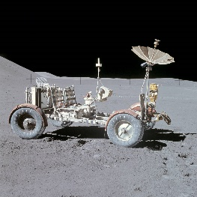
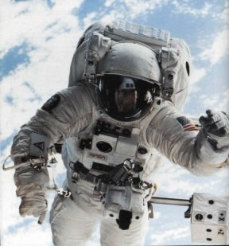
John created other innovative lubricants that could sustain a wide temperature range from -50°F to 600°F. John was challenged to create these lubricants for NASA to enable the proper function of the astronauts’ environmental control systems in their back packs, the 4-wheel drive of the moon buggy and moving parts in the missiles launched for moon expedition so they could operate in the extreme cold and hot temperatures on the moon’s surface and in space.
John’s lubricants allowed the moving parts in astronauts’ back pack, the moon buggy and the missile itself to operate in extreme temperatures.

Other lubricants John developed were intended to increase the life of jet engines in aircraft such as the F-15 Eagle and the F-4 Phantom, allowing them to reach incredible speeds. Existing lubricants were highly ineffective, breaking down at high temperatures requiring frequent replenishment or changing. Given the design of the jet engines, this would require the complete dismantling of the jet engine which was extremely time consuming and expensive, costing the US Government millions of dollars to maintain their air fleet. John developed a lubricant so powerful and resilient, that only a small amount was required to lubricate all the moving parts of the jet engines. In fact, the life of the lubricant he created outlasted the life of the jet itself – never requiring it to be changed or replaced. This allowed US fighter jets to perform at tremendous speeds and significantly prolonged their life span, reducing the number of air craft that had to be built and dismantled for service - a tremendous savings to the US government.
Lubricants used in the F-4 Phantom and F-`5 Eagle allowed them to reach unprecedented speeds and significantly prolonged the life of the aircraft.
These lubricants and greases created for application in space and military jets also had commercial application. For example, many of the lubricants John developed are used today in commercial jets, jet pilot oxygen masks, race cars, moving parts of SCUBA gear and medical equipment, to name a few.
For his innovations in lubricants technology, John was awarded the first Robert T. Schwartz Award of the Materials Research Lab at Wright Patterson Airforce Base. Robert Schwartz was the Deputy director of the Materials Laboratory at Wright Patterson. Mr. Schwartz recognized John’s innovation and contributions and personally insured John received the recognition and promotions he deserved. Mr. Schwartz held John in high esteem, not only recognizing his talents, but also his integrity, confidence and positive attitude, even when others around him often didn’t provide him the recognition he deserved due to his race. He also recognized John always stood up for himself and others throughout his career.
John received many awards and certifications throughout his career. In 1965, he received his certificate for the Eighth Annual Space Technology Institute at the University of Connecticut. In 1966, he received his certification from the University of California, Los Angeles (UCLA) for Advanced Bearing Technology and multiple scientific and management courses and awards of achievement from Wright Patterson Airforce Base and the United States Air Force. John also received monetary awards and certificates for over 50 patents and new inventions created for the US Air Force. He was inducted in Who’s Who in Science and Technology and was elected as a member of the prestigious New York Academy of Sciences in April 1964 – an honor bestowed to only the top scientists of the world, by invitation only. John traveled the world on behalf of the US Government, presenting his achievements and developments in Fluorocarbon ethers, Fluorine-containing benzimidazoles and Perfluoroalkyl ether substituted phenyl phosphines.
John has many patents for his work. The following is a transcript from the US Patent Office of the patents filed under his name:
Patents by Inventor John B. Christian. John B. Christian has filed for patents to protect the following inventions. This listing includes patent applications that are pending as well as patents that have already been granted by the United States Patent and Trademark Office (USPTO).
- Perfluoroalkylether substituted phenyl phosphines Patent number: 4454349 Abstract: Fluorinated phosphines having the general formula ##STR1## wherein R.sub.f OR.sub.f -- is a perfluoroalkylether group containing at least one ether linkage are useful as antioxidation additives for perfluorinated fluids. Type: Grant Filed: September 14, 1982 Date of Patent: June 12, 1984 Assignee: The United States of America as represented by the Secretary of the Air Force Inventors: Christ Tamborski, Carl E. Snyder, Jr., John B. Christian
- Oxidation stable polyfluoroalkylether grease compositions Patent number: 4431556 Abstract: A grease composition comprising a major amount of a polyfluoroalkylether base fluid of the general formulaAO(CF.sub.2 CF.sub.2 O).sub.m (CF.sub.2 O).sub.n Bwherein A and B are --CF.sub.3 or --C.sub.2 F.sub.5, and m and n are integers and the sum of m+n is between 2 and 200 and the ratio n/m is in the range of 0.1:1 to 10:1, a minor amount of a thickener and an oxidation inhibiting amount of a perfluoroalkylether phenylphosphine of the general formula ##STR1## wherein a has a value of zero or 1, Ar is a phenylene or perfluorophenylene group, and --R.sub.f OR.sub.f is a perfluoroalkylether group containing at least one ether linkage. Type: Grant Filed: September 14, 1982 Date of Patent: February 14, 1984 Assignee: The United States of America as represented by the Secretary of the Air Force Inventors: John B. Christian, Christ Tamborski
- Oxidation stable polyfluoroalkylether grease compositions Patent number: 4431555 Abstract: A grease composition comprising a major amount of a polyfluoroalkylether base fluid of the general formulaC.sub.3 F.sub.7 [CF(CF.sub.3)CF.sub.2)].sub.n CF.sub.2 CF.sub.3 (a)wherein n is an integer having a value in the range of 5 to 50, orF[CF(CF.sub.3)CF.sub.2 O].sub.p CHFCF.sub.3 (b)wherein p is an integer having a value of 1 to 17, a minor amount of a thickener and an oxidation inhibiting amount of a perfluoroalkylether phenylphosphine of the general formula(O).sub.a --P--Ar-CF.sub.2 -R.sub.f OR.sub.f).sub.3wherein a has a value of zero or 1, Ar is a phenylene or perfluorophenylene group, and --R.sub.f OR.sub.f is a perfluoroalkylether group containing at least one ether linkage. Type: Grant Filed: September 14, 1982 Date of Patent: February 14, 1984 Assignee: The United States of America as represented by the Secretary of the Air Force Inventors: John B. Christian, Christ Tamborski
- Grease composition containing poly(alpha-olefin) Patent number: 4406800 Abstract: An extreme pressure grease composition capable of limiting temperature increase comprising a poly(alpha-olefin) as a base fluid and a tetralkyl ammonium smectite clay as a thickener. Antimony dialkyldithiocarbamate and molybdenum disulfide may be added to the grease composition as an extreme pressure inhibitor. Type: Grant Filed: March 23, 1982 Date of Patent: September 27, 1983 Assignee: The United States of America as represented by the Secretary of the Air Force Inventor: John B. Christian
- Grease compositions based on polyfluoroalkylethers Patent number: 4324673 Abstract: An antirust, anticorrosion grease composition comprising a major amount of a polyfluoroalkylether base fluid, a minor amount of a fluorocarbon polymer thickening agent, and a rust and corrosion inhibiting amount of a benzimidazole. Type: Grant Filed: January 16, 1981 Date of Patent: April 13, 1982 Assignee: The United States of America as represented by the Secretary of the Air Force Inventors: John B. Christian, Christ Tamborski
- Grease compositions based on fluorinated polysiloxanes Patent number: 4324671 Abstract: An antirust, anticorrosion grease composition comprising a major amount of a fluorinated polysiloxane base fluid, a minor amount of a fluorocarbon polymer thickening agent, and a rust and corrosion inhibiting amount of a benzimidazole. Type: Grant Filed: February 10, 1981 Date of Patent: April 13, 1982 Assignee: The United States of America as represented by the Secretary of the Air Force Inventors: John B. Christian, Christ Tamborski
- Fluorine-containing benzimidazoles Patent number: 4267348 Abstract: Benzimidazoles substituted in the 2-position with a perfluoroalkyleneether radical. The compounds are useful as antirust and anticorrosion additives in grease formulations based on fluorine- containing fluids. Type: Grant Filed: December 4, 1979 Date of Patent: May 12, 1981 Assignee: The United States of America as represented by the Secretary of the Air Force Inventors: Christ Tamborski, John B. Christian
- Grease compositions Patent number: 4132660 Abstract: An antirust, anticorrosion grease composition comprising a major proportion of a perfluorinated polyalkylether base fluid, a minor proportion of a fluorocarbon polymer thickening agent, and a rust and corrosion inhibiting amount of a fluorine-containing benzoxazole. Type: Grant Filed: March 1, 1978 Date of Patent: January 2, 1979 Assignee: The United States of America as represented by the Secretary of the Air Force Inventors: John B. Christian, Christ Tamborski
- Fluorine-containing benzoxazoles Patent number: 4120863 Abstract: Benzoxazoles substituted in the 2-position with a perfluoroalkylether radical and bis-benzoxazoles in which the 2-position carbon atoms of the benzoxazole rings are attached to one another with a perfluoroalkylene or perfluoroalkyleneether radical. The compounds are useful as anti-rust additives in grease formulations based on fluorine-containing fluids. Type: Grant Filed: September 27, 1977 Date of Patent: October 17, 1978 Assignee: The United States of America as represented by the Secretary of the Air Force Inventors: Christ Tamborski, John B. Christian.
Aerospace Lubricants, Inc. (ALI) and Lubrication Technology, Inc. (LTI)
John retired from Wright Patterson in 1984 as a GS-15. Upon retirement, he created his own company – Aerospace Lubricants, Inc., with partner, John Gates, based in Columbus, Ohio. John Gates had no technical background and served as an administrative business partner focused on company operations and sales. Under ALI, John Christian’s patented lubricants were developed for additional military and commercial use. These synthetic greases and lubricants were used for many applications, including the following:
- Alysin Synthetic Greases and Oils – considered the world benchmark
  - Aerospace lubricants
  - Automotive OEM lubricants
  - Household synthetic grease spray
  - Marine lubricants
  - Motorcycle chain lubricants
  - Musical Instrument lubricants
- Tribolube Synthetic Lubricants
  - Synthetic Aerospace Lubricants
  - SCUBA lubricants
  - Automotive lubricants
  - Household spray lubricants
  - Dental handpiece lubricants
  - Food Grade lubricants
  - Semiconductor and optical vacuum lubricants
John parted ways with ALI, selling his interest in the company to his then partner, John Gates. John Christian then started another company based on his patented lubricants and greases, Lubrication Technology, Inc. in Jackson, Ohio in the early 1990’s. John finally retired from his company sometime before 2010 selling his interest to his partner Gary Gooding.
Family Life
When John moved to the Dayton area around 1956, he discovered Yellow Springs, Ohio. Intrigued by the very liberal lifestyle and the more accepting attitudes of people of color, John made it a point to visit Yellow Springs often on the weekends to enjoy a beer at the Ye Olde Trail Tavern with the locals. He aspired to one day live in this small town known for its many accomplished African Americans in the life sciences and arts and “hippy” lifestyle. He and his soon to be wife, Cynthia moved to Yellow Springs in the fall of 1962, living there for 54 years.
John’s Wife – Cynthia Barbara Wilson
While still living in Dayton, John met Cynthia Barbara Wilson (1938 – present) in 1958. Cynthia, originally from Boston, Massachusetts was the eldest daughter of Daniel Feininger Wilson, Sr. (1912-1992) and Madeline Raneo Wilson (1916-2016). Daniel and Madeline Wilson also had 8 other children – 2 older brothers – Daniel F. Wilson Jr. and Antone Wilson and one younger – Thomas Wilson as well as 5 younger sisters – Deanna Wilson Fredie, Barbara Wilson Lockhart, Madeline Patricia Wilson, Susan Wilson Treacy and Jennifer Wilson Averett.
Cynthia’s father, Daniel, was a successful entrepreneur, owning his own business, the Daniel F. Wilson and Company that provided cleaning services and light construction to businesses in the Boston area. Daniel was the grandson of Caroline Feininger Wilson an immigrant from Germany and her husband, a Black man unknown to the family with the surname Wilson. Caroline and her husband had two sons, Daniel’s father, Daniel Francis Wilson (affectionately referred to as “Pop” by his granddaughter Cynthia and her siblings) and his brother (name unknown). Daniel Francis and his brother were raised in a Catholic orphanage when Caroline Feininger Wilson became ill, unable to care for her children. According to Daniel Francis Wilson, he and his brother were abused by their caregivers because of their mixed heritage. Daniel’s brother died as an infant in the orphanage, reportedly at the hands of his caregivers. Daniel Francis never got over the abuses and his brother’s death. Daniel Francis Wilson married Matilda Virginia Barnwell and together, they had 11 other children in addition to Cynthia’s father, Daniel Feininger Wilson, Sr.
Cynthia’s mother Madeline, born in Massachusetts, was the daughter of immigrants from the Cape Verde islands, Antonio Andrade dos Ramos and his wife Balbina Fernandes Gomes who arrived in the U.S around 1897. Upon entry to the United States their last name was changed to Raneo. Although Antonio and Balbina only spoke their native creole language of Portuguese (a combination of Portuguese and African languages), Antonio was a shrewd businessman that acquired land in Cape Cod that would many years later be developed as part of the prestigious Cape Cod community. Some of the land is still owned by family members today.
Cynthia grew up with her family in Boston, Massachusetts. Her life had a rocky start, for as a young girl, she contracted polio of the lungs. Her mother and father feared she would not survive. Cynthia received penicillin treatments which saved her life stopping the progression of the disease. Cynthia still has ill effects from the disease to this day, but, for the most part, was able to recover from her illness.
Cynthia and her family moved to South Braintree, Massachusetts when she was 14 years old in 1952 as her father’s company grew and became more successful. Her family was somewhat of an anomaly for the times they lived in as they were the only Black family in South Braintree and one of the wealthiest. The Wilson family was highly recognized in the community for their success and unique heritage. Although they experienced many levels of racism, they did not let the “times” limit their capabilities or success. Daniel and Madeline were avid travelers – visiting interesting locations all over the United States and the world, forging friendships and business relationships that were not common for most Blacks during this time.
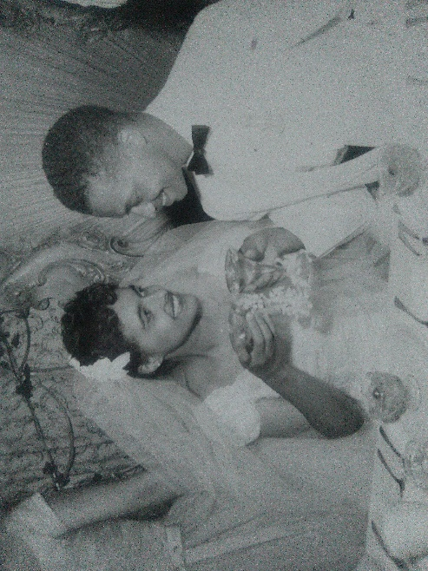
As a result of her upbringing, Cynthia also desired to see the world outside of South Braintree. In September 1958, at 19 years old, Cynthia convinced her parents to allow her to come to Dayton, Ohio with her cousin Janie to visit her Aunt Alice Raneo Giles. While visiting her Aunt Alice (affectionately called Aunt Nu-Nu), Cynthia and Janie attended a gathering where they met John Christian. John and Cynthia began to see each other socially and after just 10 dates, John asked Cynthia to be his wife. John and Cynthia wed on June 6, 1959. John was 32 and Cynthia was 20 years old. They lived in Dayton, both working at Wright Patterson Airforce Base, saving to buy a house in Yellow Springs. Cynthia joined the airforce base as a secretary in the Foreign Technology Division. After the birth of their children, she became a housewife and then eventually went back to work, this time for the Yellow Springs School system as a secretary. She retired from the Yellow Springs High School in 1993 and subsequently supported John helping with the administrative aspects of his business, Lubrication Technology, Inc.
John and Cynthia’s Children
John and Cynthia have two children, Martin Antony Christian (aka Marty 1961 – present) and Carolyn Christine Christian Bass (1962 - present). Just prior to Carolyn’s birth, John and Cynthia moved into their new home built on Omar Circle in Yellow Springs. It was the perfect environment to raise two African American children. Yellow Springs was a community that fostered a sense of “equal rights,” and “love and peace -not war.” It was a community with notable African Americans scientists, scholars and artists with a school system that instilled in all its students that they can be whatever they desired in life. A philosophy that matched the upbringing both John and Cynthia experienced growing up from family, friends and educators, even through trying times of racial discrimination. Yellow Springs was not perfect, but it was one of the more accepting communities where families could instill in their children a sense of pride in their culture and heritage and demonstrate that African Americans can aspire to do great things.
Martin Antony Christian
Their son Marty attended public school in Yellow Springs, graduating from Yellow Springs High School in 1980 and attended Clark Tech Community College in Springfield, Ohio obtaining an Associates degree in Drafting Design in 1982. Marty always preferred to work with his hands and soon after graduating from Clark Tech, he moved to Massachusetts to work for his grandfather’s company. Marty held a few other jobs, and eventually secured a position as a corrections officer for the Suffolk County House of Corrections – Sherriff’s Department. Marty is a deeply religious man and served more than a corrections officer to the inmates. He often ministered to the prisoners and is credited for helping many see the value in their lives the way God intended which put them on a more positive path in life. Marty developed a strong commitment to his country and enlisted in the United States Air National Guard in 1991 training as a Fuel Specialist. In 2000, he was deployed to Prince Sultan Air Force Base in Saudi Arabia to relieve soldiers who had been in active duty for prolonged periods. After his obligation to the military ended, Marty re-enlisted and was activated to active duty after 9-11 serving to protect the East Coast – Operation Nobel Eagle. Marty received numerous commendations for his service in each deployment. Marty retired from the Air National Guard as a Sergeant in 2011 and from the Sherriff’s department in 2014. Marty is married and living with his wife Linda Pena Christian in Randolph, Massachusetts.
Carolyn Christian Bass
Carolyn also attended public school in Yellow Springs, graduating as the valedictorian of her class from Yellow Springs High School in 1981. Her life was marked with many “firsts.” She was the first Black female valedictorian in the history of YSHS. She attended The Ohio State University, graduating with honors with a B.S. in Chemistry. While attending OSU, her exemplary grades as a freshman chemistry student caught the eye of the Dean who offered her a position as the first sophomore (Black or otherwise) to teach chemistry lab. With the Dean’s assistance and her father’s connections in the science community, she also established a co-op program for chemistry students with her assignment at Monsanto Labs. Carolyn forged friendships with Hispanic students and became a founding member of the first Hispanic co-ed fraternity in the country, Alpha Psi Lambda. After graduation from OSU, Carolyn moved to Durham, N.C. and received her MBA from the Fuqua School of Business, Duke University, graduating with honors. She then went on to work for Eli Lilly and Company, becoming the first Black female manager in the 1990’s. She then moved on to work for Coca-Cola in St. Louis in 2001. During her role as Director of Operations she was recognized by the Salt Lake Organizing Committee (SLOC) in the 2001 for running one of the most successful Olympic Torch relay celebrations. For her efforts, SLOC invited her to run in the Olympic Torch Relay and provided her the actual torch she ran with in the relay at the end of the event. Carolyn then worked for GOJO Industries in 2003, becoming the first Black executive for the company, creating the Purell Workplace Wellness Program. Shen then became a VP at AARP Services, Inc. in 2009 and then a Director at Twenty First Century Communications (TFCC), a division of West Corporation as the first Black female Director in 2012. Carolyn married in 1990 and has two children from her first marriage- Larry D. Johnson, II (Dee) born in 1997 and Christian Joseph Johnson born in 1999. Carolyn divorced in 2004 and remarried in 2013 to Darrel Bass and helped him build his company Bass International Software, serving as the Vice President of Marketing and Strategy.
Summary
John has led a tremendous life. Although he was raised in humble beginnings by multiple family members and experienced the atrocities of war and enduring racism, he was never deterred from striving for the best or reaching his goals. He always focuses on the positives – the loving family, friends and educators that supported him throughout his life; and his unique intelligence and capabilities that allowed him to achieve so many accomplishments. John lived out his dreams achieving the life he always wanted. He and his wife Cynthia instilled in their children tremendous values, including a pride in themselves, their heritage and family with an attitude that could do anything– with hard work, determination, and most of all support from a loving family.
Without John Christian, man would never have traveled in space or made it to the moon. Many people would have lost their lives in battle and the performance of so many mechanical devices in multiple industries would have been greatly compromised costing our economy millions if not billions of dollars.
John and his wife Cynthia remained in Yellow Springs until their health required them to move to South Weymouth, Massachusetts in 2015 where they had greater family support. John passed away on September 26, 2018 and was celebrated at a memorial service at St. Paul’s Catholic Church on October 27, 2018 with full military honors.

