William Edward Alexander, Sr

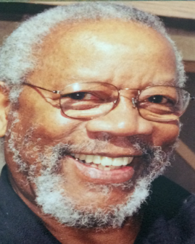
William Edward Alexander, Sr., physicist, aerospace engineer and professional magician, was born on 12 November 1934, the third of four children born to Jesse Wilson and Reella Odessa Alexander in Louisville, Kentucky. He was affectionately known as William Ed to his family and Bill to his friends. Bill graduated from Central High School in Louisville in 1952 and moved to Ohio to attend Central State University in Wilberforce, Ohio.

In 1953, while at Central State University, Bill became a member of Alpha Phi Alpha Fraternity, Inc. (Delta Xi Chapter) and was an active, life-member of this public service organization. In 1956, Bill graduated Cum Laude with a Bachelor of Science Degree in Physics. Having been a member of ROTC, Bill was commissioned and served his country in Korea first as a Lieutenant in the Army Corps of Combat Engineering where he rose quickly in the leadership ranks serving as the Corps’ youngest Company Commander. In 1960, Bill resigned from the Army Corp of Engineers and became a civilian physicist with the Flight

Dynamics Laboratory at Wright-Patterson Air Force Base (WPAFB).
Bill met and married Mary (Adams) Alexander of Xenia, Ohio. Because of the quality educational system and the diversity of the community, in 1963 they chose Yellow Springs as the place to settle and raise their four children – Noreda, William Jr., Norman, and Ivanora.

Soon after arriving in Yellow Springs, Bill became involved with the Yellow Springs Community Children’s Center – an organization he continued to support over the years. As a member and previous officer of The Yellow Springs Men’s Group, Bill arranged for magicians to perform in the “Festival of Magic” scholarship fundraisers and, in 2002, Bill served as Vice Chair of the Board of Trustees for the Leadership Institute of Yellow Springs.

In 1977, based on his continuing education, work experience, and accomplishments, Bill was offered the opportunity to enter the field of engineering business management and took on responsibility for managing the Aeromechanics Division of the Laboratory and the Mission Adaptive Wing development program at Wright-Patterson.

Bill’s professional accomplishments range from workplace to educational and social involvement. These accomplishments include over twenty published research documents, two United States patents, and 13 inventions. Some of Bill’s advanced studies included Advanced Strain Gage Techniques (University of Arizona, 1963), Laboratory Procurement Management (The Ohio State University, 1975), Radiation Heat Transfer (Louisiana State University, 1976), and Program Management (American Graduate University, 1982). As the Flight Dynamics Laboratory focal point for the Historically Black Colleges (HBC) program, Bill’s efforts resulted in the expansion of both the research and recruitment aspects of the program, as well as an increase of the laboratory’s HBC budget. Bill initiated and planned a program that reversed the declining trend in minority and female aerospace engineer employment at Wright-Patterson. For these efforts, he was presented with the Air Force Award for Notable Achievement.

After retiring in 1990, Bill continued to work as a private consultant to the US Air Force on Historically Black Colleges and Universities (HBCUs), participating in high impact ballistic studies for the improvement of military armor, and test facility instrumentation.
Bill had an extensive career as a magician. He began magic as a hobby while in junior high school and by the time he reached the 11th grade his magic performances had become semi-professional. At the age of 19, Bill became a member of the International Brotherhood of Magicians. During his years at Central State University, Bill performed magic shows at hospitals, schools, colleges, churches, in private homes, and occasionally in nightclubs. Though his magic performances after graduating from college were fewer due to his career at WPAFB, when Bill retired from WPAFB he was averaging over 100 magic shows per year. Bill performed in many locations including the states of Ohio and Kentucky; Belize, South America; and Ocho Rios, Jamaica. Bill was a life member of Society of American Magicians; Dayton Magic Club; and Louisville Magic Club, where he served as Sergeant-of-Arms; and a member of the International Brotherhood of Magicians Order of Merlin.

Bill was past member of Centennial Baptist Church (Louisville, KY), First Baptist Church (Yellow Springs, OH), Second Missionary Baptist Church (Springfield, OH), and Broadway Baptist Church (Louisville, KY).

After moving to Louisville, Kentucky in 2008, Bill continued to be active in church, with the Louisville Magic Club and, with great enjoyment, spending time with his children, grandchildren, family, and friends. William died on May 12, 2014 and is buried with his wife at the Veterans Cemetery in Fort Knox, KY.
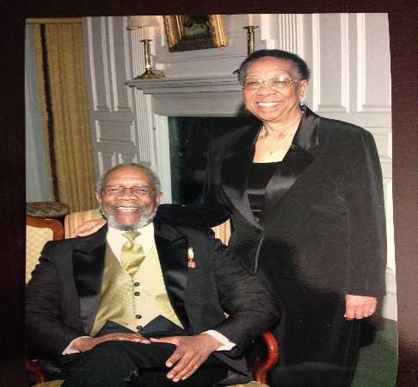
Sources:
Noreda Alexander

