Joseph Douglas Robinson
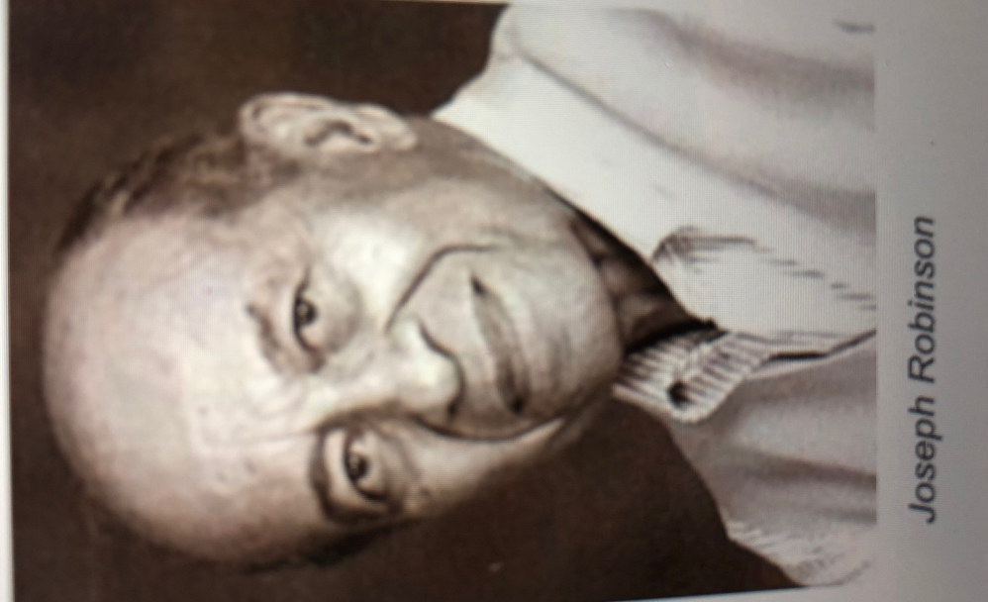

Growing up in Springfield, Ohio, Joseph Douglas Robinson was a multi-sport stand out at Catholic Central High School and a baseball star in the United States Air Force, “earning a couple of trophies for being the most valuable player in the Third Air Force, and a batch of press clippings heralding him as a “second base dynamo.” Always a sports enthusiast, while stationed at Burtonwood Air Force Base in England, Robinson was introduced to football, better known internationally as soccer, in the early 1950s.

Following his stint in the Air Force, Robinson settled in Yellow Springs in 1962 with his wife, Joyce, and their six children. Active in village life, Joe was appointed Sports and Recreation Director of the Yellow Springs Jaycees in 1964. He felt that a community sports program was needed in town—an organized team sport, geared to the spirit of sandlot fun. His vision was that “the sport should be played to build character rather than just to win. It has to teach (young People) that when you get knocked down, you get up again and go on, just as you do in life.” He believe the sport should be affordable, accessible and include a lot of participation. He decided on soccer.

The first Saturday of soccer sign ups yielded two players. The next week, 25 boys signed up to play. Coaches from Wright State University taught local volunteers about the game and a diverse group of adults refereed, timed, kept score and coached teams- now numbering about 75 boys. Joe bought eight soccer balls, NFL jerseys for players to wear- the teams were the Webb Associates Vikings, the Village Barber Shop Rams, the IGA Packers, and the Village Ford Colts- and built homemade goals. In September 1964, the Yellow Springs Soccer League was born.

Robinson ran the program, which became a model for such programs in other communities in the area, until 1977. He retired from Wright-Patterson Air Force Base in 1986 and graduated from Wittenberg University in 1999. In the course of completing his bachelor’s degree at age 69 (after beginning with night classes in 1956), he discovered his passion for painting watercolors, and his works were exhibited and collected locally, especially his portraits of the village of Yellow Springs. A village resident for over 50 years, Joe died in July of 2012, at the age of 81.

Yellow Springs Soccer League incorporated in 2006 as Yellow Springs Soccer, Incorporated, and 50 plus years later continues to serve approximately 100-250 village youth, ages 6-14, on co-ed teams. It is one of the oldest recreational soccer leagues in the Miami Valley. “We wanted the kids to have an outlet and hopefully build some character and experience, some diversity along the way, that’s why I made sure there was a racial mix on each team. The league has remained free of registration fees and continues to stress respect, responsibility, character building and fun, as Joe envisioned.

Joyce Robinson
Sources: Tom Archdeacon, “Village Set to Celebrate Youth Soccer Patriarch, The Dayton Daily News, November 5, 2009; Lauren Heaton, “YSSI Honors Founder Joe Robinson, Yellow Springs News, November 5, 2009; Lynn Railsback, “Joe Robinson’s Love for Sports Pumps Life Into Yellow Springs,” The Skywrighter, January 17, 1969

